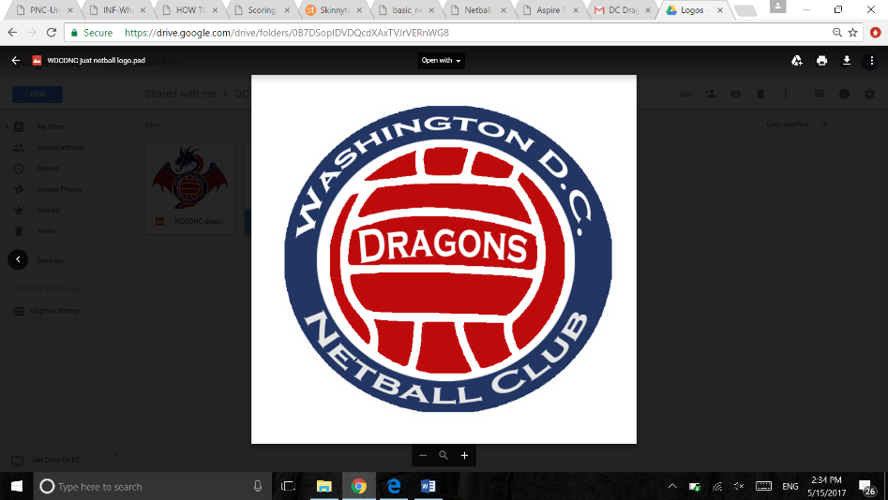Scoring a Game of Netball

The team that starts the game with the first center pass starts on EVENS.

As the game starts at 0-0 the total of the score comes to an even number. Please put an E in the box for the team that has the first center pass and an O in the box of the opponent.

|  |  |  |  |
| --- | --- | --- | --- |
| Red Team | | Blue Team | |
|  | E | O |  |
|  |  |

E: Even

O: Odd

In this example Reds have the first center pass.

Each time a goal is scored by a team the previous number is crossed out and the next number is recorded as shown below.

|  |  |  |  |
| --- | --- | --- | --- |
| Red Team | | Blue Team | |
| 1 2 3 4 5 6 | E | O | 1 2 3 |
|  |  |

**It is helpful for the people scoring to tell the umpires the score before the next center pass is taken.**

If the umpire asks you who has the next center pass. This can be worked out by adding the two scores together to find out if the total is an even or an odd number. If the score is 6 - 3 the total score comes to 9, so the team on even center passes takes the next center pass. In the above example it would be the Blue team.

If the score is an even number when added together then it would be the team taking the 'Even' centers passes turn to take a center pass.

At the end of the quarter the team that started on Evens now changes to Odds and vice versa. **EXCEPT** when a goal has just been scored and a center pass was no taken (meaning the ball was not in play). In this case E and O stays the same.

Bring down the scores into the next quarter box and circle each score. For example the ball was in play during the last quarter.

|  |  |  |  |
| --- | --- | --- | --- |
| Red Team | | Blue Team | |
| 1 2 3 4 5 6 | E | O | 1 2 3 |
|  |  |
| 6 | O | E | 3 |
|  |  |

Red team will have the next center pass when the 2nd quarter begins.

Continue scoring the game in the same way as the first quarter.

Repeat the process for each quarter.

Write the final score in the boxes at the base of the card and pass the cards back to the umpire.