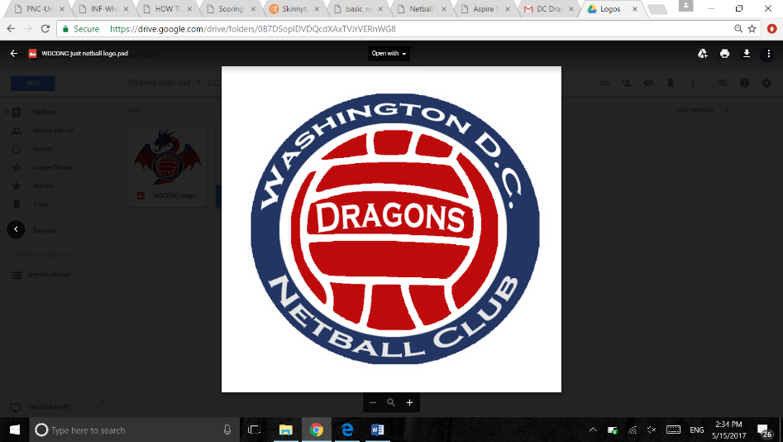Basic Netball Rules

**Players:**

Netball is played with 7 players from each team on court at one time.

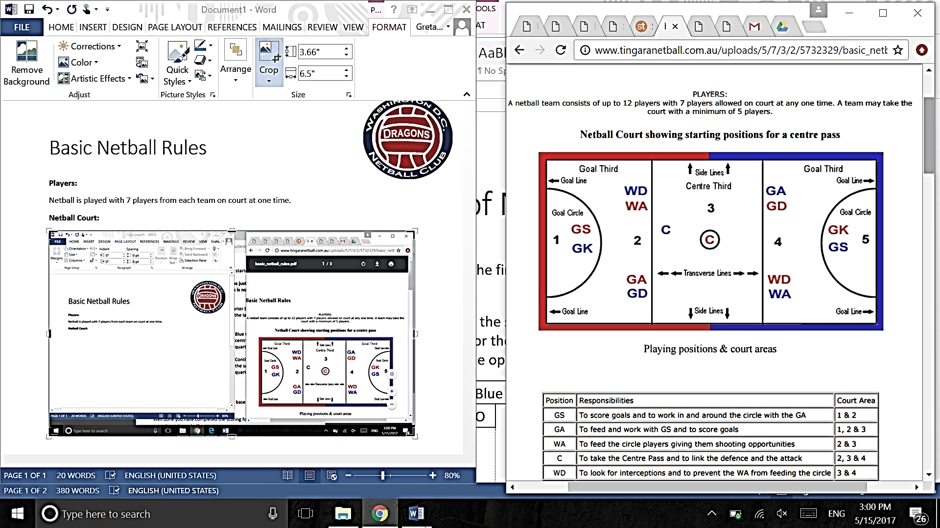**Netball Court:**

**Positions:**

GS (Goal Shooter) - Scores goals and to works in and around the circle with the GA – Court Area: 1 + 2

GA (Goal Attack) - Feeds and works with GS and to scores goals – Court Area: 1, 2 + 3

WA (Wing Attack) – Feeds to the circle players (GS and GA) giving them shooting opportunities – Court Area: 2 + 3

C (Center) - Takes the Centre Pass and links the defense and the attack – Court Area: 2, 3 + 4

WD (Wing Defense) - looks for interceptions and to prevents their opponent (WA) from feeding the circle – Court Area: 3 +4

GD (Goal Defense) – looks for interceptions and reduces the effectiveness of their opponent (GA) – Court Area: 3, 4 +5)

GK (Goal Keeper) – works with the GD and prevents the GS from scoring – Court Area: 4 + 5

**Playing the Game:**

Centre passes are taken alternately by the Centre of each team, after each goal is scored and at the start of each quarter. Each teams aim is to pass the ball to down to their goal circle and score goals (with each goal equivalent to 1 point). The team with the most goals at the end of the playing time wins the game.

**Center Pass:**

Before the whistle all players must start behind the line in the goal thirds except from the two Centers. *The Centre with the ball must have one foot in the Centre Circle and must obey the footwork rule after the whistle has been blown. The opposing Centre stands anywhere within the Centre Third and is free to move. After the whistle the center pass must be caught or touched by a player standing in or landing wholly within the center third.

**Scoring a Goal:**

Only the GS or GA can score a goal. They must be completely within the goal circle and the ball must completely go through the goal ring.

**Minor Infringements/Penalties – Free Pass:**

Breaking the following rules will result in a FREE PASS being awarded to the opposing team. When a FREE PASS is awarded to a team it may be taken by any player from that team allowed in that area, as soon as they are in position.

* **Offside:**

When a player moves out of their own area, with or without the ball

* **Breaking Center Pass:**

A player moves into center third before the whistle is blown for a center pass.

* **Playing with the Ball:**

A player who has caught or the ball shall play it or shoot for goal within three seconds.

A player may not bounce the ball.

Once released, the ball must next be touched by another player. The ball cannot be passed to oneself.

A player on the ground must stand up before playing ball.

* **Passing Distance**

There must be room for a third player between hands of thrower and catcher, this is a ‘short pass’

* **Over a Third**

Ball may not be thrown over a complete third without being touched or caught by a player wholly within that third.

* **Footwork**

Having caught the ball, a player may land or stand on:

One foot – while the landing foot remains grounded, the second foot may be moved anywhere any number of times, pivoting on the landing foot if desired. Once the landing foot is lifted, it must not be re-grounded until the ball is released.

Two feet (simultaneously) – once one foot is moved, the other is considered to be the landing foot, as above. Hopping or dragging the landing foot is not allowed.

**Major Infringements/ Penalties – Penalty Pass**

A penalty pass or penalty pass or shot (if inside the circle) is awarded where the infringement occurs. The offending player must go and stand out of play beside the thrower until the pass or shot has been taken. Any opposing player allowed in that area may take the penalty. *The opposing player can take the penalty pass before the offending player arrives. However the offending player once given penalty must head to the place where the infringement occurred.

* **Obstruction:**

Player with ball: the nearer foot of the defender must be 0.9m (3ft) feet from the landing foot of the player with the ball, or the spot where the first foot had landed if one has been lifted. The defender may jump to intercept or defend the ball from this 0.9m (3ft) feet distance.

Player without ball: the defender may be close, but not touching, providing that no effort is made to intercept or defend the ball and there is no interference with the opponents throwing or shooting action. Arms must be in a natural position, not outstretched, and no other part of the body or legs may be used to hamper an opponent.

Intimidation: of any kind, is classed as obstruction e.g. waving your hand in front of a shooters face

A standing player is not compelled to move to allow an opponent a free run, but dangerous play must be discouraged, e.g moving into the landing space of a player already in the air or stepping late into the path of a moving player.

* **Contact:**

No player may contact an opponent, either accidentally or deliberately, in such a way that interferes with the play of that opponent or causes contact to occur. This applies both when a player is and is not in play.

**Out of Court – Thrown In:**

A THROW IN is awarded to the opposing team of the player who last had contact with the ball or who received the ball whilst in contact with anything outside the court. Ball is out of court when it contacts anything outside the court area (except the goalpost). The ball is returned into play by a Throw-In taken from a point outside the court where the ball crossed the line. The player stands with foot close to the line, and the ball must be thrown onto the court within three seconds.

**Toss Up:**

This is administered for all simultaneous infringements. The two players stand facing each other at their own shooting ends with hands by their sides and the umpire flicks the ball upwards not more than 600mm (2ft) in the air as the whistle is blown.